**ESP8266**

The ESP8266 is a low-cost Wi-Fi microchip with full TCP/IP stack and microcontroller capability produced by Shanghai-based Chinese manufacturer, Espressif Systems.

The chip first came to the attention of western makers in August 2014 with the ESP-01 module, made by a third-party manufacturer, Ai-Thinker. This small module allows microcontrollers to connect to a Wi-Fi network and make simple TCP/IP connections using Hayes-style commands. However, at the time there was almost no English-language documentation on the chip and the commands it accepted. The very low price and the fact that there were very few external components on the module which suggested that it could eventually be very inexpensive in volume, attracted many hackers to explore the module, chip, and the software on it, as well as to translate the Chinese documentation. The ESP8285 is an ESP8266 with 1 MB of built-in flash, allowing for single-chip devices capable of connecting to Wi-Fi. The successor to these microcontroller chips is the ESP32.

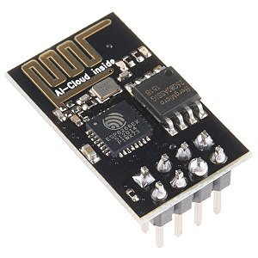

Fig ESP-01 module by Ai-Thinker

**Features**

* Processor: L106 32-bit RISC microprocessor core based on the Tensilica Xtensa Diamond Standard 106Micro running at 80 MHz.
* 32 KB instruction RAM.
* 32 KB instruction cache RAM.
* 80 KB user data RAM.
* 16 KB ETS system data RAM.
* External QSPI flash: up to 16 MB is supported (512 KiB to 4 MB typically included).
* IEEE 802.11 b/g/n Wi-Fi.
* Integrated TR switch, balun, LNA, power amplifier and matching network.
* WEP or WPA/WPA2 authentication, or open networks.
* 16 GPIO pins.
* SPI.
* I²C (software implementation).
* I²S interfaces with DMA (sharing pins with GPIO).
* UART on dedicated pins, plus a transmit-only UART can be enabled on GPIO2.
* 10-bit ADC (successive approximation ADC).

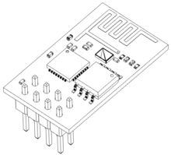

Fig ESP wireframe

**ZigBee Wireless Technology**

In this present communication world there are numerous high data rate communication standards that are available, but none of these meet the sensors’ and control devices’ communication standards. These high-data rate communication standards require low-latency and low-energy consumption even at lower bandwidths. The available proprietary wireless systems’ Zigbee technology is low-cost and low-power consumption and its excellent and superb characteristics makes this communication best suited for several embedded applications industrial control, and home automation, and so on.

**What is Zigbee Technology?**

[](https://www.elprocus.com/wp-content/uploads/2014/05/26.jpg)

Fig What is Zigbee Technology?

Zigbee communication is specially built for control and sensor networks on IEEE 802.15.4 standard for wireless personal area networks (WPANs), and it is the product from Zigbee alliance. This communication standard defines physical and Media Access Control (MAC) layers to handle many devices at low-data rates. These Zigbee’s WPANs operate at 868 MHz, 902-928MHz and 2.4 GHz frequencies. The date rate of 250 kbps is best suited for periodic as well as intermediate two-way transmission of data between sensors and controllers.

[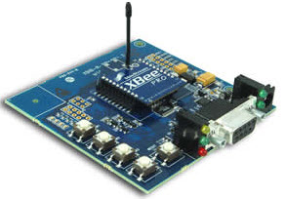](https://www.elprocus.com/wp-content/uploads/2014/05/18.jpg)

Fig Zigbee Modem

Zigbee is low-cost and low-powered mesh network widely deployed for controlling and monitoring applications where it covers 10-100 meters within the range. This communication system is less expensive and simpler than the other proprietary short-range wireless sensor networks as Bluetooth and Wi-Fi.

Zigbee supports different network configurations for master to master or master to slave communications. And also, it can be operated in different modes as a result the battery power is conserved. Zigbee networks are extendable with the use of routers and allow many nodes to interconnect with each other for building a wider area network.

**Zigbee Architecture**

[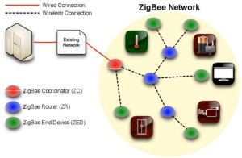](https://www.elprocus.com/wp-content/uploads/2014/05/43.jpg)

Fig Zigbee system structure

Zigbee system structure consists of three different types of devices such as Zigbee coordinator, Router and End device. Every Zigbee network must consist of at least one coordinator which acts as a root and bridge of the network. The coordinator is responsible for handling and storing the information while performing receiving and transmitting data operations. Zigbee routers act as intermediary devices that permit data to pass to and fro through them to other devices. End devices have limited functionality to communicate with the parent nodes such that the battery power is saved as shown in the figure. The number of routers, coordinators and end devices depends on the type of network such as star, tree and mesh networks.

Zigbee protocol architecture consists of a stack of various layers where IEEE 802.15.4 is defined by physical and MAC layers while this protocol is completed by accumulating Zigbee’s own network and application layers.

[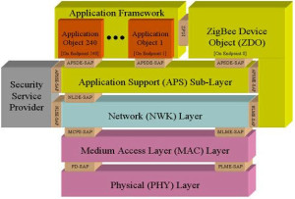](https://www.elprocus.com/wp-content/uploads/2014/05/34.jpg)

Fig Zigbee protocol architecture

**Physical Layer**: This layer does modulation and demodulation operations up on transmitting and receiving signals respectively. This layer’s frequency, date rate and number of channels are given below.

[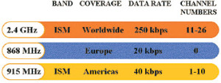](https://www.elprocus.com/wp-content/uploads/2014/05/52.jpg)

Fig Physical Layer of Zigbee Protocol

**MAC Layer**: This layer is responsible for reliable transmission of data by accessing different networks with the carrier sense multiple access collision avoidance (CSMA). This also transmits the beacon frames for synchronizing communication.

**Network Layer**: This layer takes care of all network related operations such as network setup, end device connection and disconnection to network, routing, device configurations, etc.

**Application Support Sub-Layer**: This layer enables the services necessary for Zigbee device object and application objects to interface with the network layers for data managing services. This layer is responsible for matching two devices according to their services and needs.

**Application Framework**: It provides two types of data services as key value pair and generic message services. Generic message is a developer defined structure, whereas the key value pair is used for getting attributes within the application objects.

ZDO provides an interface between application objects and APS layer in Zigbee devices. It is responsible for detecting, initiating and binding other devices to the network.

**Zigbee Operating Modes and Its Topologies**

[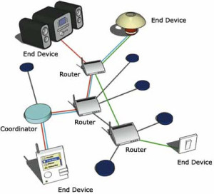](https://www.elprocus.com/wp-content/uploads/2014/05/92.jpg)

Fig Zigbee Communication Operation

Zigbee two-way data is transferred in two modes: Non-beacon mode and Beacon mode. In a beacon mode, the coordinators and routers continuously monitor active state of incoming data hence more power is consumed. In this mode, the routers and coordinators do not sleep because at any time any node can wake up and communicate. However, it requires more power supply and its overall power consumption is low because most of the devices are in an inactive state for over long periods in the network.

In a beacon mode, when there is no data communication from end devices, then the routers and coordinators enter into sleep state. Periodically this coordinator wakes up and transmits the beacons to the routers in the network. These beacon networks are work for time slots which means, they operate when the communication needed results in lower duty cycles and longer battery usage. These beacon and non-beacon modes of Zigbee can manage periodic (sensors data), intermittent (Light switches) and repetitive data types.

**Zigbee Topologies**

[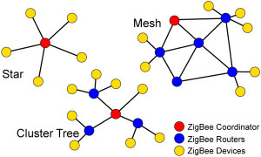](https://www.elprocus.com/wp-content/uploads/2014/05/73.jpg)

Fig Zigbee Topologies

Zigbee supports several network topologies; however, the most commonly used configurations are star, mesh and cluster tree topologies. Any topology consists of one or more coordinator. In a star topology, the network consists of one coordinator which is responsible for initiating and managing the devices over the network. All other devices are called end devices that directly communicate with coordinator. This is used in industries where all the end point devices are needed to communicate with the central controller, and this topology is simple and easy to deploy.

In mesh and tree topologies, the Zigbee network is extended with several routers where coordinator is responsible for staring them. These structures allow any device to communicate with any other adjacent node for providing redundancy to the data. If any node fails, the information is routed automatically to other device by these topologies. As the redundancy is the main factor in industries, hence mesh topology is mostly used. In a cluster-tree network, each cluster consists of a coordinator with leaf nodes, and these coordinators are connected to parent coordinator which initiates the entire network.

Due to the advantages of Zigbee technology like low cost and low power operating modes and its topologies, this short-range communication technology is best suited for several applications compared to other proprietary communications, such as Bluetooth, Wi-Fi, etc. some of these comparisons such as range of Zigbee, standards, etc., are given below.

[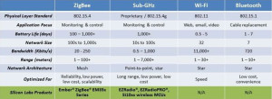](https://www.elprocus.com/wp-content/uploads/2014/05/82.jpg)

Fig Comparison Table of Zigbee

**Applications of Zigbee Technology**

[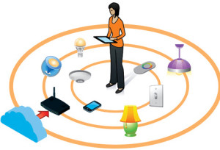](https://www.elprocus.com/wp-content/uploads/2014/05/63.jpg)

Fig Applications of Zigbee Technology

**Industrial Automation:** In manufacturing and production industries, a communication link continually monitors various parameters and critical equipment’s. Hence Zigbee considerably reduce this communication cost as well as optimizes the control process for greater reliability.

**Home Automation:** Zigbee is perfectly suited for controlling home appliances remotely as a lighting system control, appliance control, heating and cooling system control, safety equipment operations and control, surveillance, and so on.

**Smart Metering:** Zigbee remote operations in smart metering include energy consumption response, pricing support, security over power theft, etc.

**Smart Grid monitoring:** Zigbee operations in this smart grid involve remote temperature monitoring, fault locating, reactive power management, and so on.

**Interfacing zigbee with 8051**

Fig. shows how to interface the Zigbee with microcontroller. The Xbee modules work at the 2.4 GHz frequency which means smaller board and antenna size. Xbee modules have the ability to transmit Digital, PWM, Analog or Serial RS232 signals wirelessly. To communicate over UART or USART, we just need three basic signals which are namely, RXD (receive), TXD (transmit), GND (common ground). So to interface UART with 8051, we just need the basic signals.

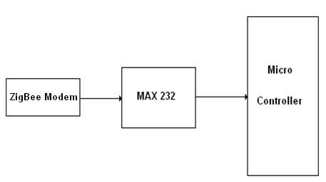

Fig.  Interfacing Zigbee to Microcontroller

We now want to interface the ZigBee module with 8051 Development board for accessing the mobiles without wires through UART0. The data communication is done in internet by using the ZigBee module through MAX232 into the SBUF register of 8051 microcontroller (refer serial interfacing with 8051). The serial data from the Zigbee receiver is taken by using the Serial Interrupt of the controller. +5V and ground is connected to provide power to the module. While TX and RX pin is connected for communication.

Pin Assignment with 8051

|  |  |  |  |
| --- | --- | --- | --- |
|  | UART DB-9 Connector | 8051  Lines | Serial Port Section |
| UART0(P1)  ISP PGM | TXD-0 | P3.0 | |  | | --- | | serial port section 8051 | |
| RXD-0 | P3.1 |
| UART1  (P2) | TXD-1 | P1.2 |
| RXD-1 | P1.3 |

Circuit Diagram to Interface Zigbee with 8051

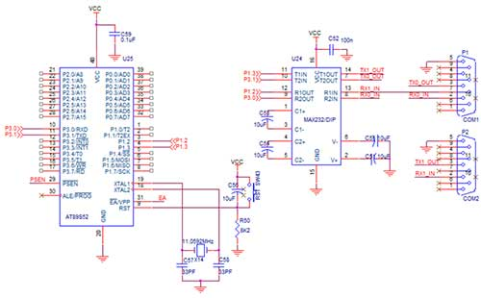

**IR SENSORS**

Infrared technology addresses a wide variety of wireless applications. The main areas are sensing and remote controls. In the electromagnetic spectrum, the infrared portion is divided into three regions: near infrared region, mid infrared region and far infrared region.

The wavelengths of these regions and their applications are shown below.

* Near infrared region — 700 nm to 1400 nm — IR sensors, fiber optic
* Mid infrared region — 1400 nm to 3000 nm — Heat sensing
* Far infrared region — 3000 nm to 1 mm — Thermal imaging

The frequency range of infrared is higher than microwave and lesser than visible light.

For optical sensing and optical communication, photo optics technologies are used in the near infrared region as the light is less complex than RF when implemented as a source of signal. Optical wireless communication is done with IR data transmission for short range applications. An infrared sensor emits and/or detects infrared radiation to sense its surroundings.

The working of any Infrared sensor is governed by three laws: Planck’s Radiation law, Stephen – Boltzmann law and Wien’s Displacement law.

Planck’s law states that “every object emits radiation at a temperature not equal to 00K”. Stephen – Boltzmann law states that “at all wavelengths, the total energy emitted by a black body is proportional to the fourth power of the absolute temperature”. According to Wien’s Displacement law, “the radiation curve of a black body for different temperatures will reach its peak at a wavelength inversely proportional to the temperature”.

The basic concept of an Infrared Sensor which is used as Obstacle detector is to transmit an infrared signal, this infrared signal bounces from the surface of an object and the signal is received at the infrared receiver.

There are five basic elements used in a typical infrared detection system: an infrared source, a transmission medium, optical component, infrared detectors or receivers and signal processing. Infrared lasers and Infrared LED’s of specific wavelength can be used as infrared sources. The three main types of media used for infrared transmission are vacuum, atmosphere and optical fibers. Optical components are used to focus the infrared radiation or to limit the spectral response.

Optical lenses made of Quartz, Germanium and Silicon are used to focus the infrared radiation. Infrared receivers can be photodiodes, phototransistors etc. some important specifications of infrared receivers are photosensitivity, detectivity and noise equivalent power. Signal processing is done by amplifiers as the output of infrared detector is very small.

**Types of IR Sensors**

Infrared sensors can be passive or active. Passive infrared sensors are basically Infrared detectors. Passive infrared sensors do not use any infrared source and detects energy emitted by obstacles in the field of view. They are of two types: quantum and thermal. Thermal infrared sensors use infrared energy as the source of heat and are independent of wavelength. Thermocouples, pyroelectric detectors and bolometers are the common types of thermal infrared detectors.

Quantum type infrared detectors offer higher detection performance and are faster than thermal type infrared detectors. The photosensitivity of quantum type detectors is wavelength dependent. Quantum type detectors are further classified into two types: intrinsic and extrinsic types. Intrinsic type quantum detectors are photoconductive cells and photovoltaic cells.

Active infrared sensors consist of two elements: infrared source and infrared detector. Infrared sources include an LED or infrared laser diode. Infrared detectors include photodiodes or phototransistors. The energy emitted by the infrared source is reflected by an object and falls on the infrared detector.

[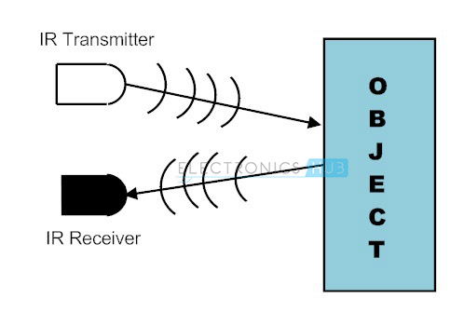](https://www.electronicshub.org/wp-content/uploads/2015/01/1.-IR-Sensors.jpg)

Fig IR sensor working

**IR Transmitter**

Infrared Transmitter is a light emitting diode (LED) which emits infrared radiations. Hence, they are called IR LED’s. Even though an IR LED looks like a normal LED, the radiation emitted by it is invisible to the human eye.

The picture of a typical Infrared LED is shown below.

[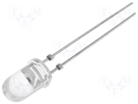](https://www.electronicshub.org/wp-content/uploads/2015/01/IR-LED.png)

Fig IR transmitter

There are different types of infrared transmitters depending on their wavelengths, output power and response time.

A simple infrared transmitter can be constructed using an infrared LED, a current limiting resistor and a power supply. The schematic of a typical IR transmitter is shown below.

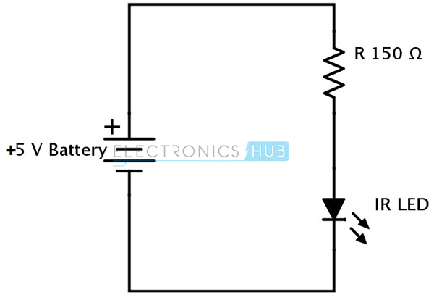

Fig IR transmitter circuit

When operated at a supply of 5V, the IR transmitter consumes about 3 to 5 mA of current. Infrared transmitters can be modulated to produce a particular frequency of infrared light. The most commonly used modulation is OOK (ON – OFF – KEYING) modulation.

IR transmitters can be found in several applications. Some applications require infrared heat and the best infrared source is infrared transmitter. When infrared emitters are used with Quartz, solar cells can be made.

**IR Receiver**

Infrared receivers are also called as infrared sensors as they detect the radiation from an IR transmitter. IR receivers come in the form of photodiodes and phototransistors. Infrared Photodiodes are different from normal photo diodes as they detect only infrared radiation. The picture of a typical IR receiver or a photodiode is shown below.

[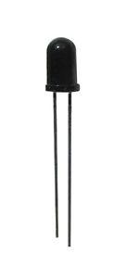](https://www.electronicshub.org/wp-content/uploads/2015/01/IR-Receiver.jpg)

Fig IR receiver

Different types of IR receivers exist based on the wavelength, voltage, package, etc. When used in an infrared transmitter – receiver combination, the wavelength of the receiver should match with that of the transmitter.

A typical infrared receiver circuit using a phototransistor is shown below.

[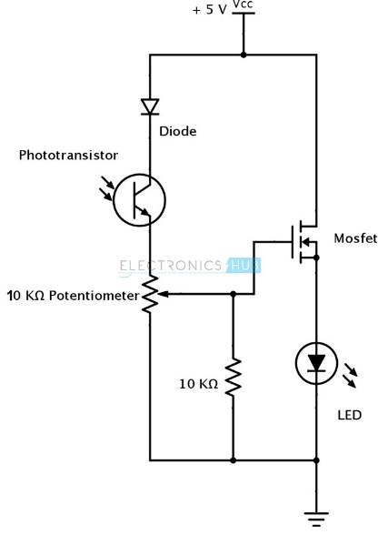](https://www.electronicshub.org/wp-content/uploads/2015/01/3.-Infrared-Receiver.jpg)

Fig IR receiver circuit

It consists of an IR phototransistor, a diode, a MOSFET, a potentiometer and an LED. When the phototransistor receives any infrared radiation, current flows through it and MOSFET turns on. This in turn lights up the LED which acts as a load. The potentiometer is used to control the sensitivity of the phototransistor.

**Principle of Working**

The principle of an IR sensor working as an Object Detection Sensor can be explained using the following figure. An IR sensor consists of an IR LED and an IR Photodiode; together they are called as Photo – Coupler or Opto – Coupler.

[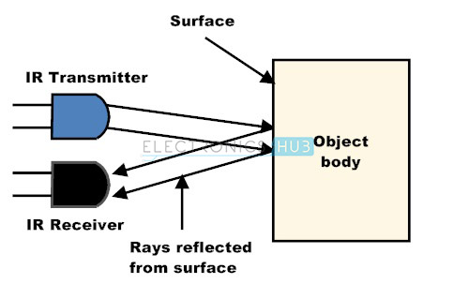](https://www.electronicshub.org/wp-content/uploads/2015/01/4.-Working-principle-of-IR-sensor.jpg)

Fig object detection sensor.

When the IR transmitter emits radiation, it reaches the object and some of the radiation reflects back to the IR receiver. Based on the intensity of the reception by the IR receiver, the output of the sensor is defined.

**Obstacle Sensing Circuit or IR Sensor Circuit**

A typical IR sensing circuit is shown below.

[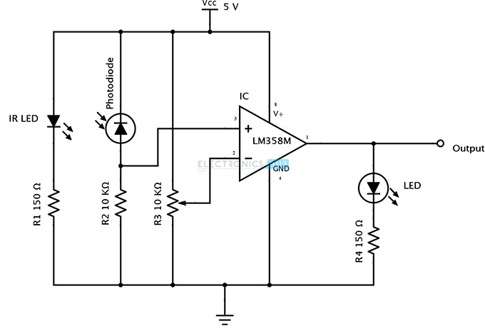](https://www.electronicshub.org/wp-content/uploads/2015/01/5.-IR-Sensor-Circuit.jpg)

Fig IR sensing circuit

It consists of an IR LED, a photodiode, a potentiometer, an IC Operational amplifier and an LED.

IR LED emits infrared light. The Photodiode detects the infrared light. An IC Op – Amp is used as a voltage comparator. The potentiometer is used to calibrate the output of the sensor according to the requirement.

When the light emitted by the IR LED is incident on the photodiode after hitting an object, the resistance of the photodiode falls down from a huge value. One of the input of the op – amp is at threshold value set by the potentiometer. The other input to the op-amp is from the photodiode’s series resistor. When the incident radiation is more on the photodiode, the voltage drop across the series resistor will be high. In the IC, both the threshold voltage and the voltage across the series resistor are compared. If the voltage across the resistor series to photodiode is greater than that of the threshold voltage, the output of the IC Op – Amp is high. As the output of the IC is connected to an LED, it lightens up. The threshold voltage can be adjusted by adjusting the potentiometer depending on the environmental conditions.

The positioning of the IR LED and the IR Receiver is an important factor. When the IR LED is held directly in front of the IR receiver, this setup is called Direct Incidence. In this case, almost the entire radiation from the IR LED will fall on the IR receiver. Hence there is a line of sight communication between the infrared transmitter and the receiver. If an object falls in this line, it obstructs the radiation from reaching the receiver either by reflecting the radiation or absorbing the radiation.

**8051 Microcontroller**

The 8051 Microcontroller was designed in 1980’s by Intel. Its foundation was on Harvard Architecture and was developed principally for bringing into play in Embedded Systems. At first it was created by means of NMOS technology but as NMOS technology needs more power to function therefore Intel re-intended Microcontroller 8051 employing CMOS technology and a new edition came into existence with a letter ‘C’ in the title name, for illustration: 80C51. These most modern Microcontrollers need fewer amount of power to function in comparison to their forerunners.

There are two buses in 8051 Microcontroller one for program and other for data. As a result, it has two storage rooms for both program and data of 64K by 8 size. The microcontroller comprises of 8 bit accumulator & 8 bit processing unit. It also consists of 8-bit B register as majorly functioning blocks and 8051 microcontroller programming is done with embedded C language using Keil software. It also has a number of other 8 bit and 16-bit registers.

For internal functioning & processing Microcontroller 8051 comes with integrated built-in RAM. This is prime memory and is employed for storing temporary data. It is unpredictable memory i.e. its data can get be lost when the power supply to the Microcontroller switched OFF.

**8051 Microcontroller Architecture:**

Microcontroller 8051 block diagram is shown below. Let’s have a closer look on features of 8051 microcontroller design:

[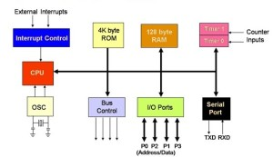](https://www.elprocus.com/wp-content/uploads/2013/02/Block-Diagram-of-8051-Microcontroller.jpg)

Block Diagram of 8051 Microcontroller

**CPU (Central Processor Unit):**

As you may be familiar that Central Processor Unit or CPU is the mind of any processing machine. It scrutinizes and manages all processes that are carried out in the Microcontroller. User has no power over the functioning of CPU. It interprets program printed in storage space (ROM) and carries out all of them and do the projected duty. CPU manages different types of registers in 8051 microcontroller.

**Interrupts:**

As the heading put forward, Interrupt is a sub-routine call that reads the Microcontroller’s key function or job and helps it to perform some other program which is extra important at that point of time. The characteristic of 8051 Interrupt is extremely constructive as it aids in emergency cases. Interrupts provides us a method to postpone or delay the current process, carry out a sub-routine task and then all over again restart standard program implementation.

The Micro-controller 8051 can be assembled in such a manner that it momentarily stops or break the core program at the happening of interrupt. When sub-routine task is finished then the implementation of core program initiates automatically as usual. There are 5 interrupt supplies in 8051 Microcontroller, two out of five are peripheral interrupts, two are timer interrupts and one is serial port interrupt.

**Memory:**

Micro-controller needs a program which is a set of commands. This program enlightens Microcontroller to perform precise tasks. These programs need a storage space on which they can be accumulated and interpret by Microcontroller to act upon any specific process. The memory which is brought into play to accumulate the program of Microcontroller is recognized as Program memory or code memory. In common language it’s also known as Read Only Memory or ROM.

Microcontroller also needs a memory to amass data or operands for the short term. The storage space which is employed to momentarily data storage for functioning is acknowledged as Data Memory and we employ Random Access Memory or RAM for this principle reason. Microcontroller 8051 contains code memory or program memory 4K so that is has 4KB Rom and it also comprise of data memory (RAM) of 128 bytes.

**Bus:**

Fundamentally Bus is a group of wires which functions as a communication canal or mean for the transfer Data. These buses comprise of 8, 16 or more cables. As a result, a bus can bear 8 bits, 16 bits all together. There are two types of buses:

1. **Address Bus:** Microcontroller 8051 consists of 16-bit address bus. It is brought into play to address memory positions. It is also utilized to transmit the address from Central Processing Unit to Memory.
2. **Data Bus:** Microcontroller 8051 comprise of 8 bits data bus. It is employed to cart data.

**Oscillator:**

As we all make out that Microcontroller is a digital circuit piece of equipment, thus it needs timer for its function. For this function, Microcontroller 8051 consists of an on-chip oscillator which toils as a time source for CPU (Central Processing Unit). As the productivity thumps of oscillator are steady as a result, it facilitates harmonized employment of all pieces of 8051 Microcontroller. Input/output Port: As we are acquainted with that Microcontroller is employed in embedded systems to manage the functions of devices.

Thus, to gather it to other machinery, gadgets or peripherals we need I/O (input/output) interfacing ports in Micro-controller. For this function Micro-controller 8051 consists of 4 input/output ports to unite it to other peripherals.

**Timers/Counters:**

Micro-controller 8051 is incorporated with two 16 bit counters & timers. The counters are separated into 8-bit registers. The timers are utilized for measuring the intervals, to find out pulse width etc.

**8051 Microcontroller Pin Diagram**

[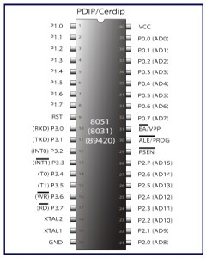](https://www.elprocus.com/wp-content/uploads/2013/02/8051-Microcontroller-Pin-Diagram.jpg)

Fig 8051 Microcontroller Pin Diagram

For explaining the pin diagram and pin configuration of microcontroller 8051, we are taking into deliberation a 40 pin Dual inline package (DIP). Now let’s study through pin configuration in brief:

**Pins 1 – 8:** recognized as Port 1. Different from other ports, this port doesn’t provide any other purpose. Port 1 is a domestically pulled up, quasi bi-directional Input/output port.

**Pin 9:** As made clear previously RESET pin is utilized to set the micro-controller 8051 to its primary values, whereas the micro-controller is functioning or at the early beginning of application. The RESET pin has to be set elevated for two machine rotations.

**Pins 10 – 17:** recognized as Port 3. This port also supplies a number of other functions such as timer input, interrupts, serial communication indicators TxD & RxD, control indicators for outside memory interfacing WR & RD, etc. This is a domestic pull up port with quasi bi-directional port within.

**Pins 18 and 19:** These are employed for interfacing an outer crystal to give system clock.

**Pin 20:** Titled as Vss – it symbolizes ground (0 V) association.

**Pins- 21-28:** recognized as Port 2 (P 2.0 – P 2.7) – other than serving as Input/output port, senior order address bus indicators are multiplexed with this quasi bi-directional port.

**Pin- 29:** Program Store Enable or PSEN is employed to interpret sign from outer program memory.

**Pin-30:** External Access or EA input is employed to permit or prohibit outer memory interfacing. If there is no outer memory need, this pin is dragged high by linking it to Vcc.

**Pin-31:** Aka Address Latch Enable or ALE is brought into play to de-multiplex the address data indication of port 0 (for outer memory interfacing). Two ALE throbs are obtainable for every machine rotation.

**Pins 32-39:** recognized as Port 0 (P0.0 to P0.7) – other than serving as Input/output port, low order data & address bus signals are multiplexed with this port (to provide the use of outer memory interfacing). This pin is a bi directional Input/output port (the single one in microcontroller 8051) and outer pull up resistors are necessary to utilize this port as Input/output.

**Pin-40:** termed as Vcc is the chief power supply. By and large it is +5V DC.

**Applications of 8051 Microcontroller:**

The microcontroller 8051 applications include large amount of machines, principally because it is simple to incorporate in a project or to assemble a machine around it. The following are the key spots of spotlight:

1. **Energy Management:** Competent measuring device systems aid in calculating energy consumption in domestic and industrialized applications. These meter systems are prepared competent by integrating microcontrollers.
2. **Touch screens:** A high degree of microcontroller suppliers integrate touch sensing abilities in their designs. Transportable devices such as media players, gaming devices & cell phones are some illustrations of micro-controller integrated with touch sensing screens.
3. **Automobiles:** The microcontroller 8051 discovers broad recognition in supplying automobile solutions. They are extensively utilized in hybrid motor vehicles to control engine variations. In addition, works such as cruise power and anti-brake mechanism has created it more capable with the amalgamation of micro-controllers.
4. **Medical Devices:** Handy medicinal gadgets such as glucose & blood pressure monitors bring into play micro-controllers, to put on view the measurements, as a result, offering higher dependability in giving correct medical results.
5. **Medical Devices:** Handy medicinal gadgets such as glucose & blood pressure monitors bring into play micro-controllers, to put on view the measurements, as a result, offering higher dependability in giving correct medical results.